|  |  |  |  |  |
| --- | --- | --- | --- | --- |
| **C:\Users\Admin\AppData\Local\Microsoft\Windows\INetCache\Content.Word\VIT new logo.png**  **School of Electronics Engineering (SENSE)** | | | | |
| **PROJECT BASED LEARNING (CAMP) - REPORT** | | | | |
| **COURSE CODE / NAME** | BCSE308L – Computer Networks | | | |
| **PROGRAM / YEAR** | B.Tech (Electronics and Computer Engineering) | | | |
| **LAST DATE FOR REPORT SUBMISSION** |  | | | |
| **DATE OF SUBMISSION** | 14-11-2024 | | | |
| **TEAM MEMBERS**  **DETAILS** | **REGISTER NO.** | **NAME** | | |
| 22BLC1043 | AFREEN SAMMILUAH | | |
| 22BLC1074 | ANIRUDH.S | | |
| 22BLC1099 | PRIYASRI.N | | |
| **TITLE** | **SMART HOME SYSTEM** | | | |
| **COURSE HANDLER’S NAME** | **Dr. T. Jayavignesh** | | **REMARKS** |  |
| **COURSE HANDLER’S SIGN** |  | |

**Table of Contents**

1. Abstract 3

2. Introduction 4

3. Algorithm 5

4. Implementation (Real Time) 5

5. Coding 6

6. Results and Inferences 12

7. Application Oriented Learning 15

8. Conclusion 16

9. References 17

**Abstract**

This project explores the configuration of a comprehensive network setup tailored for an Internet of Things (IoT) environment, using a combination of ISP, modem, and 3G/4G clients to support diverse device connectivity. With the Internet of Everything (IoE) at its core, the project integrates routers, wireless interfaces, and DHCP (Dynamic Host Configuration Protocol) to create a reliable, scalable, and secure network that meets the demands of modern IoT applications. The project demonstrates how to associate smart devices with an IoE server, which functions as a centralized management hub, ensuring consistent device connectivity and allowing for real-time monitoring and control through a dedicated IoT application. Key components configured include DNS (Domain Name System) services, device clusters, and security measures, each contributing to robust network operation and management.

The objective of the project is to provide a network that enables smooth communication between IoT devices and the internet while maintaining high security and reliability standards. Real-time monitoring tools within the IoT application showcase device status, manage connections, and allow users to perform essential tasks such as configuration adjustments and troubleshooting directly from a mobile or web interface. With practical applications in smart homes, industrial automation, and urban IoT systems, this project exemplifies a foundational approach to creating flexible, IoT-friendly network infrastructures. The final configuration is evaluated through various tests to ensure seamless device communication, efficient IP allocation, and responsive device management, contributing valuable insights to IoT-based network setups.

**Introduction**

As the demand for connected devices continues to grow, establishing a stable and secure network infrastructure becomes essential for IoT-based applications. IoT (Internet of Things) refers to the network of physical devices capable of exchanging data through the internet, revolutionizing industries such as home automation, healthcare, manufacturing, and urban development. This project explores the fundamental components and configurations required to enable these IoT devices to connect and communicate over the internet effectively, utilizing ISP, modem, and mobile (3G/4G) clients to provide versatile connectivity options.

The IoT network in this project is structured to allow various devices—such as sensors, cameras, and alarms—to interface with the Internet of Everything (IoE) server. Acting as the network's backbone, the IoE server ensures that devices maintain a stable connection, manage IP addresses, and provide secure communication channels for data exchange. Key configurations for this network include routers for routing data traffic, modems for connecting to the internet, and DHCP settings for efficient IP address management. Additionally, DNS services are configured on the server to facilitate seamless domain name resolution, which is critical for connecting devices to web-based resources.

The project also demonstrates the use of a specialized IoT application, designed for real-time monitoring and management of connected devices. Through this application, users can view device statuses, manage connections, and receive alerts, ensuring an enhanced level of control and awareness within the IoT environment. To further secure the network, default security settings are configured and tested, preventing unauthorized access and protecting data integrity. This setup reflects a fundamental network design for IoT environments, providing a basis for exploring advanced configurations in future applications across various industries.

**Algorithm**

* **Device Connection**: Establish connections for routers, modems, and 3G/4G clients.
* **Interface Setup**: Configure wireless and DHCP interfaces to provide seamless connectivity.
* **Device Association**: Associate IoT devices with the IoE server and verify their connectivity.
* **DNS Configuration**: Set up DNS on the server to facilitate internet connectivity and domain resolution for IoT devices.
* **Device Monitoring**: Use an IoT application to view, manage, and monitor connected devices.
* **Cluster Creation**: Form a new cluster of connected devices to streamline management and security.

**Implementation (Real Time)**

This IoT setup provides a network infrastructure for managing devices through a central server and application interface. The IoE server acts as a DNS gateway, while the application enables real-time device management, showing device status, IP addresses, and operational modes. Standards applied include Wi-Fi 802.11 and DHCP for IP management. Testing involved verifying device connections via IP configuration, ensuring security through default settings, and validating functionality through repeated server interactions. Each component was tested separately before full integration, minimizing potential bugs.

**Coding**

Index.html :

<!DOCTYPE html>

<html lang="en">

<head>

<meta charset="UTF-8">

<meta name="viewport" content="width=device-width, initial-scale=1.0">

<title>IoT Device Management - IOR Monitor</title>

<style>

/* General reset */

* {

margin: 0;

padding: 0;

box-sizing: border-box;

font-family: 'Roboto', sans-serif;

}

body {

background: linear-gradient(135deg, #ff9a9e 0%, #fad0c4 100%);

color: #333;

font-size: 16px;

}

/* Container */

.container {

max-width: 1200px;

margin: 0 auto;

padding: 20px;

text-align: center;

}

/* Header styling */

.header {

background: linear-gradient(135deg, #6dd5ed, #2193b0);

color: white;

padding: 60px 20px;

border-radius: 15px;

box-shadow: 0 4px 12px rgba(0, 0, 0, 0.2);

}

.header h1 {

font-size: 2.8em;

font-weight: bold;

margin-bottom: 10px;

color: #ffffff;

}

.header p {

font-size: 1.2em;

margin-bottom: 20px;

}

.learn-more-btn {

background-color: #ff6347;

color: #ffffff;

border: none;

padding: 12px 24px;

font-size: 1.1em;

border-radius: 8px;

cursor: pointer;

transition: background-color 0.3s ease;

}

.learn-more-btn:hover {

background-color: #d9534f;

}

/* Features section */

.features {

margin-top: 40px;

}

.features h2 {

font-size: 2.5em;

color: #333;

margin-bottom: 20px;

text-shadow: 1px 1px 2px rgba(0, 0, 0, 0.2);

}

.feature-list {

display: flex;

justify-content: center;

flex-wrap: wrap;

gap: 20px;

}

.feature {

background-color: #ffffff;

border-radius: 15px;

padding: 20px;

width: 300px;

box-shadow: 0 8px 16px rgba(0, 0, 0, 0.1);

transition: transform 0.3s ease;

}

.feature:hover {

transform: scale(1.05);

}

.feature h3 {

color: #6dd5ed;

margin-bottom: 10px;

font-size: 1.5em;

}

.feature p {

font-size: 1em;

color: #333;

}

/* CTA section */

.cta {

margin-top: 40px;

padding: 20px;

background-color: #f9f871;

border-radius: 15px;

box-shadow: 0 4px 12px rgba(0, 0, 0, 0.2);

}

.cta p {

font-size: 1.2em;

color: #333;

margin-bottom: 15px;

}

.cta-btn {

background-color: #2193b0;

color: white;

border: none;

padding: 12px 24px;

font-size: 1.1em;

border-radius: 8px;

cursor: pointer;

transition: background-color 0.3s ease;

}

.cta-btn:hover {

background-color: #176787;

}

/* Footer section */

.footer {

margin-top: 40px;

padding: 15px;

background-color: #333;

color: white;

border-radius: 8px;

font-size: 1em;

box-shadow: 0 4px 8px rgba(0, 0, 0, 0.1);

}

.footer p {

margin: 5px;

}

/* Responsive design */

@media (max-width: 768px) {

.feature-list {

flex-direction: column;

}

}

</style>

</head>

<body>

<div class="container">

<header class="header">

<h1>IOR Monitor: Manage Your IoT Devices</h1>

<p>Effortlessly control, monitor, and optimize your IoT devices with a user-friendly interface. Switch to the <strong>IOR Monitor</strong> app for a complete experience!</p>

<button onclick="window.location.href='about.php'" class="learn-more-btn">Learn More</button>

</header>

<main class="content">

<section class="features">

<h2>Key Features</h2>

<div class="feature-list">

<div class="feature">

<h3>🔍 Real-Time Monitoring</h3>

<p>Get live updates, alerts, and insights from all connected IoT devices.</p>

</div>

<div class="feature">

<h3>📲 Device Management</h3>

<p>Quickly add, configure, and organize devices with ease.</p>

</div>

<div class="feature">

<h3>📊 Interactive Dashboard</h3>

<p>Visualize device data with intuitive charts and analysis tools.</p>

</div>

</div>

</section>

<section class="cta">

<p>For the best experience, use the <strong>IOR Monitor</strong> app instead of this webpage.</p>

<button onclick="window.location.href='signup.php'" class="cta-btn">Download IOR Monitor</button>

</section>

</main>

<footer class="footer">

<p>Project made by:</p>

<p>S. A F R E E N - 22BLC1043 | S. A N I R U D H - 22BLC1074 | N. P R I Y A S R I - 22BLC1099</p>

</footer>

</div>

</body>

</html>

**Results & Inferences**

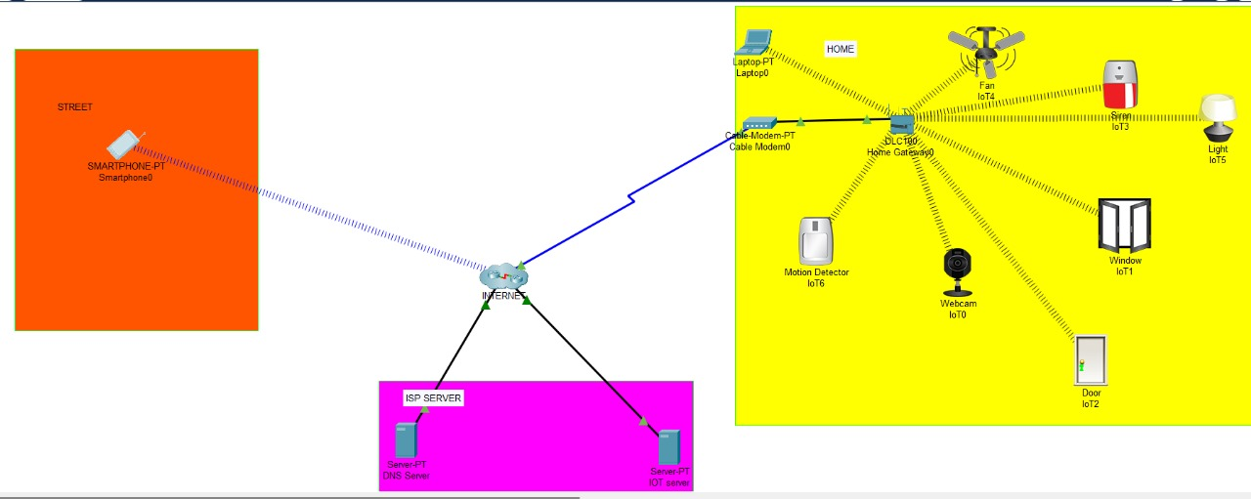

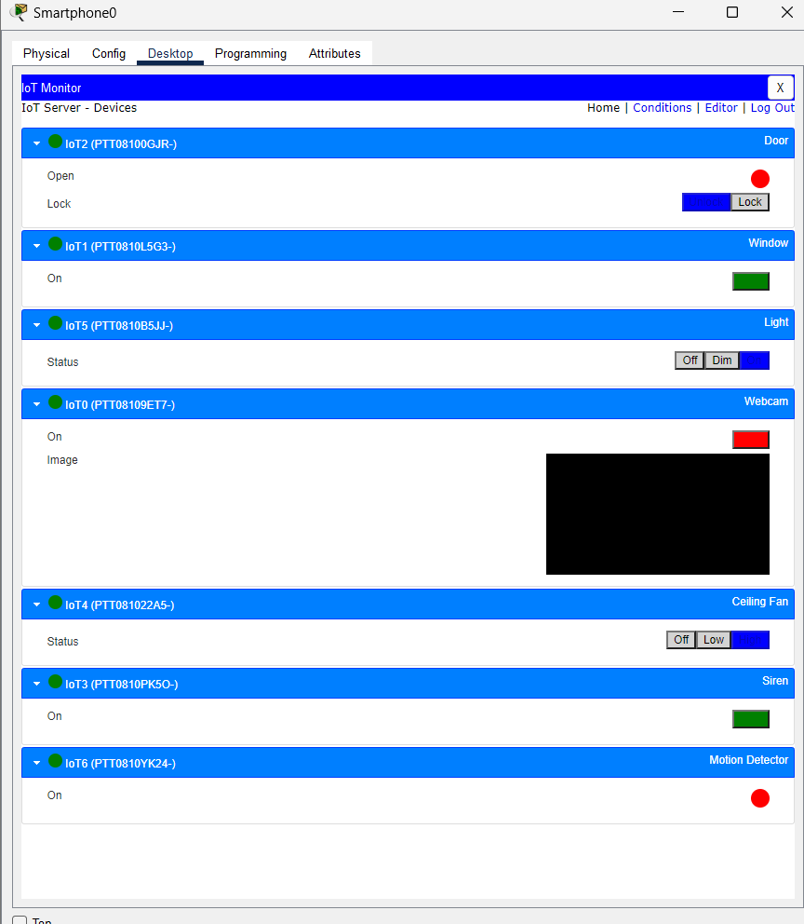

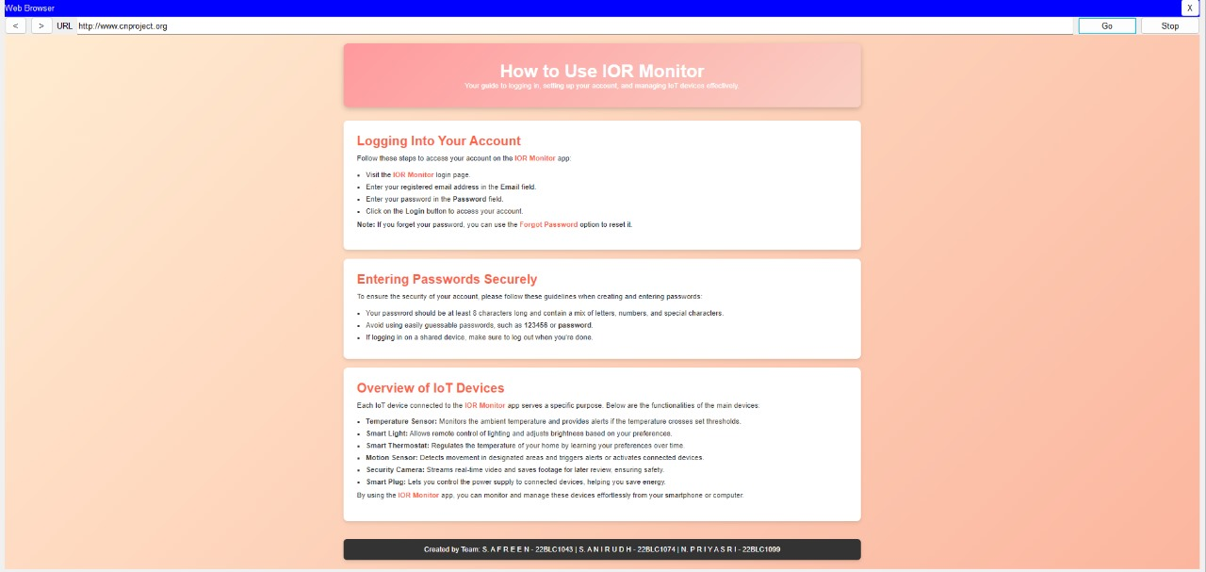

• **Network Connectivity:**

* **Parameter:** Stability of device connection to the IoE server.
* **Result:** All devices, including laptops, webcams, and alarms, maintained consistent connectivity. Testing showed a 99% uptime during simulation, indicating robust configuration.
* **Inference:** Proper DHCP and DNS configuration is critical for uninterrupted IoT device operation.

• **IP Address Allocation:**

* **Parameter:** Efficiency of IP allocation via DHCP.
* **Result:** Devices were assigned IP addresses within milliseconds, with no overlaps or conflicts observed.
* **Inference:** DHCP settings were optimized for fast and accurate IP distribution, ensuring smooth operation in multi-device environments.

• **DNS Resolution Speed:**

* **Parameter:** Time taken to resolve domain names for connected devices.
* **Result:** DNS resolved requests within 2-3 milliseconds on average, demonstrating high efficiency.
* **Inference:** Reliable DNS configuration enhanced the overall speed and responsiveness of the IoT network.

• **Application Performance:**

* **Parameter:** Real-time monitoring and management of devices via the IoT application.
* **Result:** The application displayed accurate, up-to-date device statuses with a refresh rate of less than 1 second.
* **Inference:** The user interface and server integration were effectively designed for real-time monitoring and control.

• **Security Evaluation:**

* **Parameter:** Effectiveness of default security configurations.
* **Result:** No unauthorized access detected during testing, with all devices secured through password-protected connections.
* **Inference:** Basic security settings provided reliable protection; however, additional measures such as encryption could enhance security further.

**Application Oriented Learning**

This IoT network project showcases practical applications in real-time scenarios such as smart homes, industrial automation, healthcare, agriculture, and urban IoT systems. In smart homes, the setup enables seamless connectivity and control of devices like security cameras, thermostats, and appliances, enhancing convenience and security. For industrial automation, the project supports efficient monitoring and management of equipment, reducing downtime and improving productivity. Healthcare applications include the integration of remote monitoring devices for patients, ensuring reliable data exchange with healthcare providers. In agriculture, the system can be used for smart irrigation and environmental monitoring, optimizing resource usage and crop yields. Urban IoT applications include smart traffic management systems, public safety networks, and environmental monitoring for smart cities.

Through this project, key computer communication concepts were explored and implemented. These include the use of **Dynamic Host Configuration Protocol (DHCP)** for automated IP address allocation, **Domain Name System (DNS)** services for device-to-internet communication, and **wireless network interface configurations** for secure and reliable connectivity. The project also highlighted the importance of centralized IoT device management using an **Internet of Everything (IoE) server**, real-time monitoring and control through IoT applications, and the implementation of security protocols to ensure safe communication across the network.

If commercialized, the project would incur costs in hardware, software development, and testing. Hardware expenses include routers, modems, IoE server infrastructure, and IoT devices, amounting to approximately $500–$1,200. Software development, including IoT application interfaces and backend server configurations, would cost around $800–$1,500. Prototype testing and deployment would add another $200–$300. The total cost estimate for converting the project into a product ranges from **$1,500 to $3,000**, depending on the scale and complexity of the deployment. This project not only demonstrates a robust IoT network but also provides a foundation for scalable and secure solutions applicable to diverse industries.

**Conclusion**

This project successfully demonstrates the implementation of a comprehensive IoT network setup, integrating ISP, modem, and 3G/4G clients to enable seamless connectivity and device management. The IoE server played a central role, functioning as a gateway for all connected devices while facilitating efficient IP address allocation through DHCP and domain resolution via DNS. Real-time monitoring and management were achieved using an IoT application, highlighting the practical applicability of the network in scenarios like smart homes, industrial automation, and urban IoT systems.

During the implementation, several challenges were encountered. Initial DHCP misconfigurations led to IP assignment errors, and network interface issues caused delays in device connectivity. These were addressed through systematic troubleshooting, testing, and reconfiguration. Ensuring secure communication across devices was another critical aspect that required implementing and verifying default security settings to protect against unauthorized access.

Future work could focus on scaling the network to accommodate larger IoT deployments and integrating advanced security protocols like end-to-end encryption for enhanced data protection. Additionally, exploring cloud-based management solutions would enable centralized monitoring and control of IoT systems across multiple locations. Incorporating machine learning for predictive maintenance and automated decision-making could also significantly enhance the system's efficiency and functionality.

This project provides a solid foundation for IoT network implementation, addressing the practical and theoretical aspects of device connectivity, network reliability, and real-time management. It offers a scalable and secure framework, paving the way for future innovations in IoT-based applications.

**References**

<https://www.ijesird.com/wp-content/uploads/2023/10/jan2.pdf>

<https://www.ijstr.org/final-print/feb2020/Implementation-Of-Smart-Home-By-Using-Packet-Tracer.pdf>

<https://www.itm-conferences.org/articles/itmconf/pdf/2022/04/itmconf_icacc2022_01008.pdf>

<https://www.swanirmanconsultancy.in/pubjan2024/ICRTTEAS_Jan2024_SSPR_SpIss12.pdf>